صورة تحتوي على زهرة, خزامى, بنفسجي, نبات

قد يكون المحتوى الذي تم إنشاؤه بواسطة الذكاء الاصطناعي غير صحيح.صورة تحتوي على زهرة, خزامى, بنفسجي, نبات

قد يكون المحتوى الذي تم إنشاؤه بواسطة الذكاء الاصطناعي غير صحيح. LAVENDER SWEET

WEP class project, academic year 2025 /2026

|  |  |  |  |  |
| --- | --- | --- | --- | --- |
| Student Name in English | Student Name in Arabic | Student ID | Section time as shown in zajel | Work percentage |
| Sara Othman Shehadi | سارة عثمان شحادة | 12323745 | 9.5-11 | 100% |

---------------------------------------------This section is intended for the Instructor---------------------------------------

|  |  |
| --- | --- |
| **Topic** | **Mark** |
| Project Requirements and Modeling |  |
| Correctness of Database mapping |  |
| Functional Dependency and Normalization |  |
| Project Tools |  |
| Project Discussion |  |
| Project Completeness |  |
| Project Output Results or reporting (JasperReport, charts, graphs, etc.) |  |
| Project Administration and Management |  |
| Project Report |  |
| Project Idea |  |
| Project Complexity |  |

# Abstract

This project is called **Lavender Sweet**, a chocolate shop website.  
The website lets users see chocolate products, read details, and buy them online.  
It has a simple and beautiful design, easy to navigate.

The website includes:

* **Home Page** – displays all products briefly and attractively
* **Product Page** – shows product details, including picture, price, and description
* **Cart Page** – allows adding and removing products and shows total price
* **Login Page** – lets users log in to their accounts
* **Register Page** – lets users create a new account
* **Checkout Page** – for completing purchases
* **Filter Page** – to search or filter products by price or type

This project helped me learn **HTML, CSS, PHP, and MySQL**. It also taught me how to create a full website and manage a database.

Table of Contents

Abstract

Introduction 3

Project Requirements 3

Functional Dependencies 4

Project ER Diagram / UML 4

Normalization Process 9

Tools Used 10

GUI Discussion 10

Conclusion 19

References 19

# Introduction

In the modern world, online shopping is very popular.  
**Lavender Sweet** is a chocolate shop website that allows users to view products, see details, and buy chocolates online.

The main goals of this website are:

* To make shopping for chocolates easy and convenient
* To display all products with pictures, prices, and descriptions
* To allow users to filter products by type or price
* To provide a simple and attractive interface for a better user experience

This project helped me understand how to build a full website using **HTML, CSS, PHP, and MySQL**, and how to manage products and orders in a database.

# Project Requirements

The **Lavender Sweet** website has the following requirements:

1. **User Management**
   * Users can **register** a new account and **log in** to the website.
   * User information includes name, email, and password.
2. **Product Management**
   * Display all chocolate products on the **Home Page**.
   * Show product details, including picture, price, and description, on the **Product Page**.
   * Allow filtering products by name or type.
3. **Cart System**
   * Users can **add products** to the cart.
   * Users can **remove products** from the cart.
   * Display the **total price** of products in the cart.
4. **Checkout**
   * Users can **complete purchases** using the Checkout Page.
5. **Website Design**
   * The website must have a **simple and attractive design**.
   * It should be **easy to navigate** and user-friendly.
6. **Database Requirements**
   * Store user information, products, and cart items in a **MySQL database**.
   * Ensure data is consistent and secure.



# Functional Dependencies

**User**

id → name, type, location, password, email

**Products**

id → name, type, flavor, img, description, price

**Cart**

id → user_id, product_id, quantity

**Orders**

id → user_id, total_price, status, created_at, updated_at

**Order_Items**

id → order_id, product_id, quantity, price

Project ER Diagram / UML

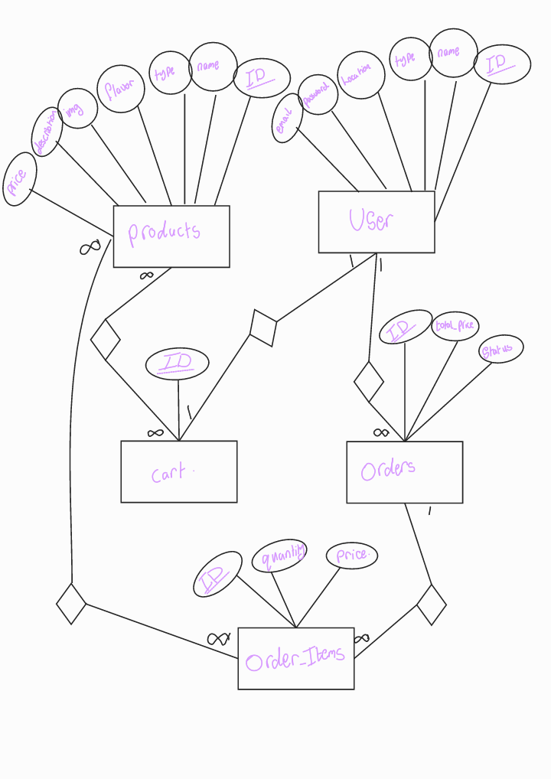

# The tables in databases:

|  |  |
| --- | --- |
|  | The Lavender Sweet website uses a **MySQL database** named “lavender sweet “to store all necessary information for users, products, cart items, and orders. The database consists of the following tables: |
|  | **The Products table**  stores all the chocolate products available on the Lavender Sweet website. It contains all the details for each product, including:   * **id** – unique identifier for each product * **name** – the product’s name * **type** – the category, such as Gift, Family, or Single * **flavor** – the chocolate flavor, such as Milk, Dark, or White * **img** – the image of the product * **description** – detailed information about the product * **price** – the cost of the product   This table ensures that all product information is organized and accessible for display on the website, filtering, and shopping cart functionality. |
|  | **Users Table**  The Users table stores information about all registered users of the Lavender Sweet website. It includes the following details for each user:   * **id** – a unique identifier for each user * **name** – the full name of the user * **type** – the role or type of user (e.g., customer, admin) * **location** – the user’s address or city * **email** – the user’s email address for login and communication * **password** – the user’s account password (stored securely)   This table ensures that all user information is properly organized and linked to their cart and orders, allowing personalized experiences such as adding products to the cart, making purchases, and managing their accounts. |
|  | **Cart Table**  The Cart table stores all products that users have added to their shopping carts before completing a purchase. It includes the following details:   * id – a unique identifier for each cart entry * user_id – links the cart item to the specific user * product_id – links the cart item to the specific product * quantity – the number of units of the product added to the cart   This table ensures that each user’s cart is separate and private. All actions, such as adding, removing, or changing product quantities, are recorded in this table and updated dynamically in the database. It allows the website to display accurate cart contents and calculate the total price for each user before checkout.  أعلى النموذج  **أسفل النموذج** |
|  | **Orders Table**  The Orders table stores information about all purchases made by users on the Lavender Sweet website. It includes the following fields:   * **id** – a unique identifier for each order * **user_id** – links the order to the specific user who made the purchase * **total_price** – the total cost of all products in the order * **payment_status** – indicates whether the payment has been made; currently, this field is not processed in the project but can be used in future development to track payments * **order_status** – shows the current status of the order, such as pending, completed, or shipped   Although the **payment_status** is not handled in this version of the project, including this field allows for future development where online payments can be integrated. The table ensures that all orders are recorded accurately and linked to the respective users, providing a foundation for managing order history and tracking their progress |
|  | **Order_Items Table**  The Order_Items table stores information about each individual product included in an order on the Lavender Sweet website. It includes the following fields:   * id – a unique identifier for each order item * order_id – links the item to a specific order in the Orders table * product_id – links the item to a specific product in the Products table * quantity – the number of units of the product in the order * price – the price of a single unit of the product at the time of purchase   This table allows the website to keep track of which products are included in each order and their quantities. It ensures accurate calculation of the total price and provides detailed information for each order, making it possible to display order details to users and manage order processing efficiently. |

# Normalization Process

**The database of Lavender Sweet was normalized to avoid data duplication and to keep every table organized and clear.  
The normalization process went through the common three levels: 1NF, 2NF, and 3NF.**

**1. First Normal Form (1NF)**

In this step, every table was checked to make sure that:

* Each field contains only one value.
* There are no repeated groups.
* Every table has a primary key.

All tables in the project (users, products, cart, orders, order_items) satisfy 1NF.

**2. Second Normal Form (2NF)**

In this step, we make sure that:

* Each table is already in 1NF.
* Every column depends only on the primary key.

Since all tables use a simple primary key (ID), the database naturally satisfies 2NF.

**3. Third Normal Form (3NF)**

In this step, we check that:

* The table is in 2NF.
* There are no columns that depend on other non-primary columns.

In Lavender Sweet:

* All columns in each table depend only on the ID of the table.
* There is no unnecessary dependency.

So all tables are already in 3NF.

**4. Final Result**

**All tables in the Lavender Sweet database successfully meet 1NF, 2NF, and 3NF.  
The database is clean, organized, and free from data duplication.**

Tools Used

- **Database:** MySQL

- **Backend Language:** PHP

- **Frontend Languages:** HTML, CSS

- **Server Environment:** XAMPP (Apache + MySQL)

-**Diagramming Tool:** Draw.io (for ER Diagram & Database structure)

# GUI Discussion

|  |  |
| --- | --- |
|  | Lavender Sweet website was designed with a simple, clean, and user-friendly interface to make the shopping experience easy and enjoyable for users.  The goal of the UI was to create a smooth navigation flow so visitors can quickly browse products, view details, and complete their purchases. |
|  | The header of the Lavender Sweet website is simple and clear, appearing at the top of every page to help users navigate easily. It includes links to the main pages: Home, Products, Cart, and Login/Register. The header uses a clean purple design and stays fixed while scrolling, making navigation fast and convenient for users. |
|  | This section, titled *“Step Into Our Chocolate Museum”*, showcases four featured chocolate products. Each box contains an image and a short description. When a user **hovers** over a box, a nice gesture appears.  When a user **clicks** on a box, they are taken to the product’s detail page, where they can see full information about the product. This effect makes the section interactive, visually appealing, and easy to navigate. |
|  | The *About Us* section shares the story of Lavender Sweet, explaining how the brand started, its core values, and what makes its chocolates unique. It helps visitors connect with the brand, understand its mission, and feel the care and creativity behind every product. |
|  | When clicking the *About* button, users see the story and values of Lavender Sweet. It explains how the brand started from small creative ideas and grew into a caring, thoughtful chocolate brand. It highlights the brand’s values like authenticity, quality, comfort, and empowerment, and shows what makes the products special — unique flavors, attention to detail, and a personal touch. This section helps visitors understand the brand’s mission and feel connected to its story. |
|  | At the bottom of the home page, there is a *Packages* section with three boxes: **Gift, Family, and Single**. When a user clicks on a box, they are taken to a separate page showing products filtered by that category. This makes it easy for visitors to quickly find the type of chocolates they are looking for. The section also includes a tagline: *“Life is sweeter with a touch of chocolate* 💜”, adding a friendly and inviting feel. |
|  | The website’s footer include navigation and social media links.   * Clicking the **logo** always returns the user to the **home page**. * Social media icons link to the brand’s pages: **Facebook** and **Instagram** work and open the project’s pages, while **Pinterest** and **TikTok** have no pages, so they do not link anywhere. * The footer also includes a **filter feature**, allowing users to view products by category quickly and easily. |
|  | Users can access the **Products page** directly from the header navigation. This page shows all chocolate products with images, prices, and short descriptions. From here, users can click on a product to see its **detailed page**, where they can view more information, add it to the cart, and make a purchase. This makes browsing and shopping easy and organized. |
|  | When users open the Products page, they can see all available chocolate products with their name and price.  The page includes two filters to help find products easily:  Flavor filter – choose between Milk, Dark, or White chocolate.  Category filter – choose between Gift, Family, or Single products. |
|  | The website allows users to filter products easily using the available selection options. Users can choose a single filter, for example **“Gift”**, and the system will display only products that belong to that category. Multiple filters can also be applied simultaneously, such as **“Gift”** and **“Dark”**, in which case only products that satisfy both criteria are shown.  All product data, including name, price, flavor, and category, is stored in the **database**, so the filtering is applied dynamically based on the stored information. This ensures that users always see accurate results according to their selections, providing a smooth and interactive browsing experience. |
|  | When a user clicks on a product from the Products page, they are taken to the **Product Details page**. This page shows:   * The **product image**. * The **name, description, and price** of the product. * An **Add to Cart** button to quickly add the product to the shopping cart.   There is also a **Back to Products** link that returns the user to the main Products page. This page helps users see full details of a product before buying, making the shopping |
|  | When a user clicks the "Add to Cart" button on the product details page, a confirmation message is sent, and the product is added to the shopping cart table in the database.  If the user is logged in, the products are added successfully, and a confirmation message appears on the page. |
|  | If the user is not logged in, a prompt appears asking them to log in before adding products to the shopping cart.  This ensures that only logged-in users can save products for checkout, while also providing clear feedback to the user. |
|  | To access features like adding products to a shopping cart or viewing personalized orders, users must log in.  The login page is located at the top of each page, where users can enter their ID and password.  Once logged in, they can add products to their shopping cart, proceed to checkout, and manage their accounts. |
|  | If a visitor does not have an account, they can **create a new account** through the **Sign Up / Register page**, which is also accessible from the **header**. By registering, users can log in, add products to the cart, make orders, and manage their profile. |
| ئ | Users can also register or log in using their Google account. After logging in with Google, once accepted, they are directed to the address addition page, and then directly to the products page to begin shopping. This ensures a smooth process for new users while collecting the necessary order information. |
|  | Once a user **logs in**, the **header** updates automatically: the "Login" link changes to "Logout". Users can click **Logout** at any time to sign out of their account, ensuring easy access to login and logout actions from any page. |
|  | At the Header, the Contact section allows users to reach out easily.  Clicking on the section shows a simple Contact Us form with fields for Name, Email, and Message, along with a Phone Number and Email address for support.  Although the account information and contact details are sample data, this section demonstrates a clear and user-friendly way for customers to send inquiries or messages to the shop. |
|  | The **Cart** is always accessible from the **header** at the top of the website, making it easy for users to view their selected products at any time. If a visitor tries to open the cart **without logging in**, a message appears telling them to log in first. Clicking on it **takes them directly to the Login page**, ensuring that only registered users can add items and complete purchases. |
|  | Once a user logs in, the **Cart** in the header becomes fully functional and updates dynamically with every action. Users can **increase or decrease the quantity** of each product using the + and - buttons next to it. The cart also provides two main buttons: **“Clear Cart”** to remove all items and **“Checkout”** to proceed with the payment. This makes managing products and completing orders easy, smooth, and interactive. |
|  | When the user clicks **“Clear Cart”**, all items are removed from the cart immediately. Any action—adding, removing, or changing the quantity of a product—is **automatically updated in the database**, so the cart always reflects the correct data for that user.  When a user clicks **“Clear Cart”**, it only affects **their own cart**. For example, if user 222 clears their cart, user 111’s cart remains unchanged. All cart operations are **linked to the logged-in user in the database**, so each user’s cart is separate and private. |
|  | When the user clicks on **Checkout**, the invoice page appears showing all the order details. Then, when the user presses the **Confirm** button, a new page appears saying that the order was completed successfully. On this same page, a button also appears that allows the user to go back to the **Home Page**. |

# 

# Conclusion

In conclusion, this project successfully demonstrated the complete process of designing and implementing a relational database system for an e-commerce website, **Lavender Sweet**. Starting from the conceptual design using an Entity-Relationship Diagram (ERD), we identified the main entities such as **Users, Products, Cart, Orders, and Order Items**, along with their relationships.

The database schema was then implemented in **MySQL**, ensuring that all primary keys, foreign keys, and integrity constraints were properly defined. To guarantee a robust design, the schema was normalized step by step, progressing from **First Normal Form (1NF) .**Through this process, data redundancy was eliminated, partial and transitive dependencies were removed, and overall data consistency was improved.

Additionally, functional dependencies for each relation were analyzed, confirming that all attributes are fully dependent on their primary keys. The system supports key functionalities such as **user management, product organization, cart operations, orders, and role-based access** for customers and administrators.

The final design provides a scalable and efficient solution that ensures data integrity, prevents anomalies (insertion, update, deletion), and supports a smooth and interactive user experience. Users can browse products, filter by category or flavor, view detailed information, manage their cart, and complete purchases seamlessly.

Overall, the project highlights the importance of systematic database design, normalization, and functional dependency analysis in building a reliable, real-world e-commerce platform..

References

* Database Systems lectures.
* Web programming lectures.

HTML, CSS, PHP, MySQL official documentation.

صورة تحتوي على خزامى, أرجواني, زهرة, الطبيعة

قد يكون المحتوى الذي تم إنشاؤه بواسطة الذكاء الاصطناعي غير صحيح.

صورة تحتوي على خزامى, أرجواني, زهرة, الطبيعة

قد يكون المحتوى الذي تم إنشاؤه بواسطة الذكاء الاصطناعي غير صحيح.